How to Complete & Pull a Timecard

- Log into Paychex

- Go to Time & Attendance from the left-hand panel
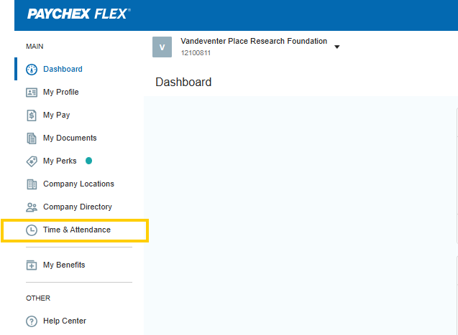

- Next select the correct pay period and then “Edit”
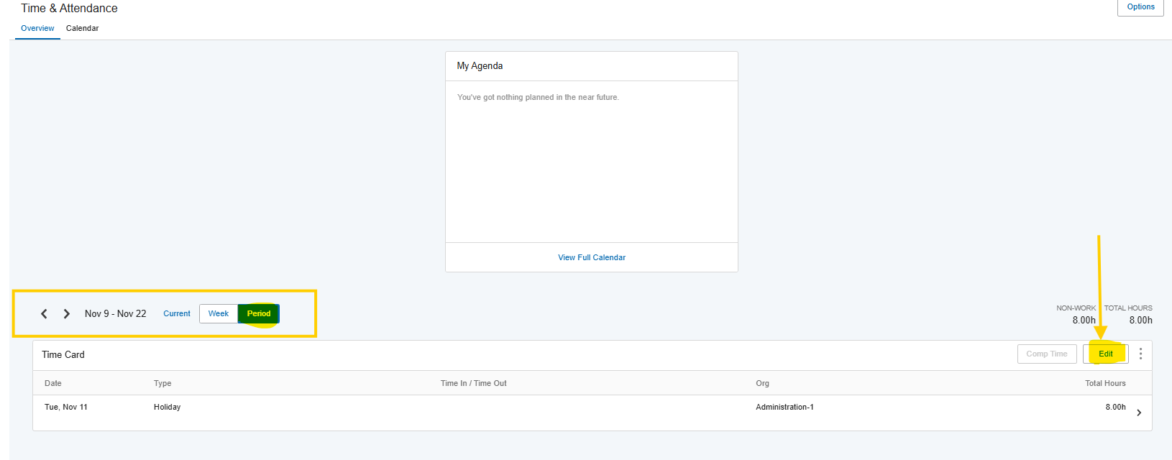

- You have 2 different options to complete your timecard:

  - One option is to select “Autofill” from the top of the banner (highlighted in yellow). This will autofill your timecard based on your Paychex profile and your “Default” organization (study) you are assigned to. Please ensure that the breakdown of hours and organization/labor distribution (studies) reflect the actual hours worked for each study.

  - Another option is to manually complete the timecard. First select the “Type” (Work, Sick, Unpaid, or Vacation) of hours worked, manually enter the number of hours worked, and then select the Organization. The Organization and Labor Distribution should be the specific study or project you are assigned to and should be the same. Please ensure you select the same Organization type and Labor Distribution.

  - As a reminder, any holidays or approved leave requests will auto populate in your timecard. Examples highlighted below.

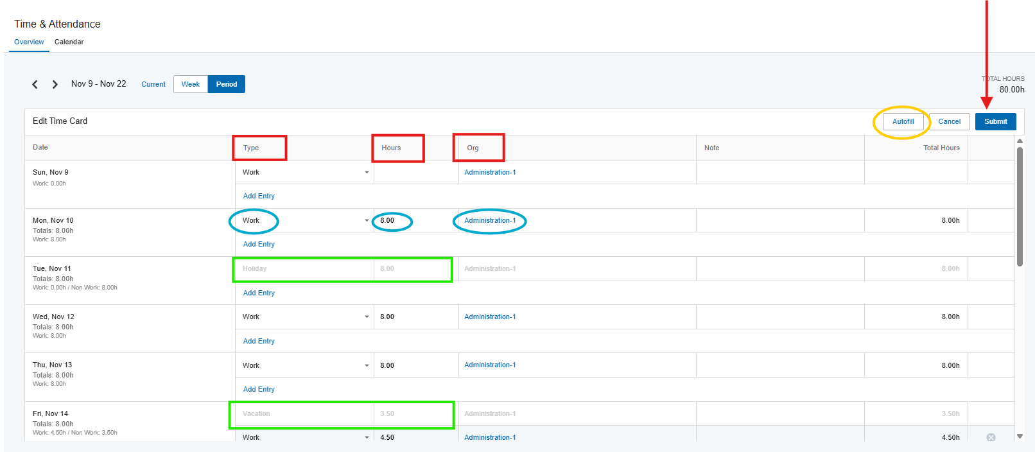

- Once you complete your timecard, hit “Submit” & select the ellipsis:
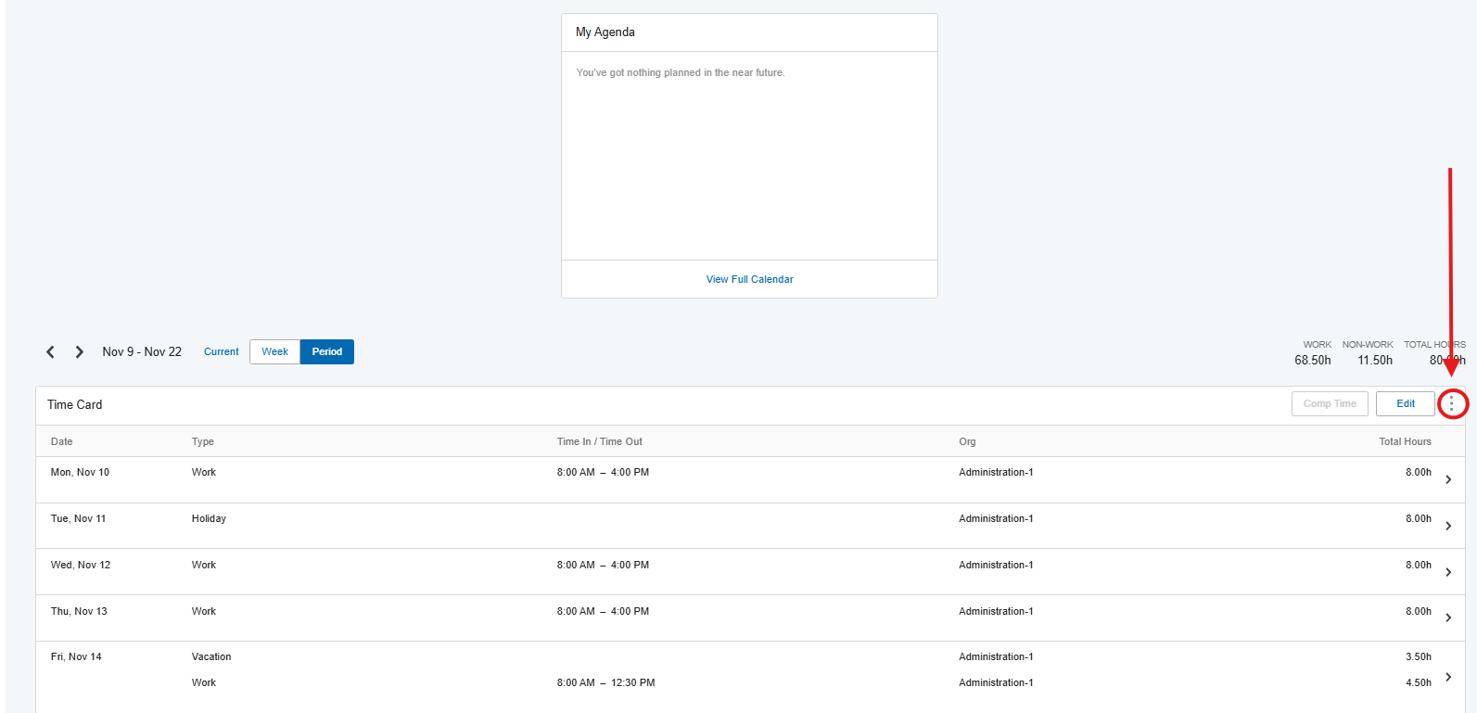

- On the “Email Timecard Report” Screen, ensure the correct pay period auto populates, select “PDF,” confirm the email you would like the timecard sent to, and then “Send Report.”
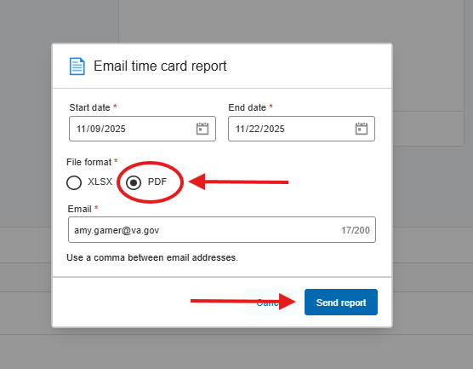

- You will receive an email from no-reply@centralservers.coms with your Time Card.
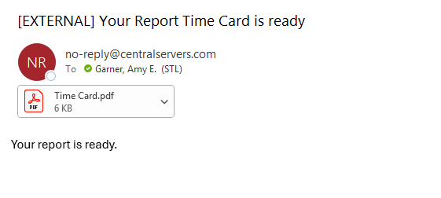
- Please save your Time Card with the following information: Time Card, Pay Period, & Your Last Name
  - Example: Time Card 11.09.25 to 11.22.25 Garner

- As reminder, timecards need to be signed by your PI or Supervisor. Once signed, please send the signed copy to the VREF Operations Manager and VREF Finance Director by close of business the Tuesday of the pay period.

